PLACES
I. Look at the pictures and write the names of the places in your notebook. Look at the example.
I. (Pogledaj slike i napiši nazive mjesta u školsku svesku. Vidi urađeni primjer.)
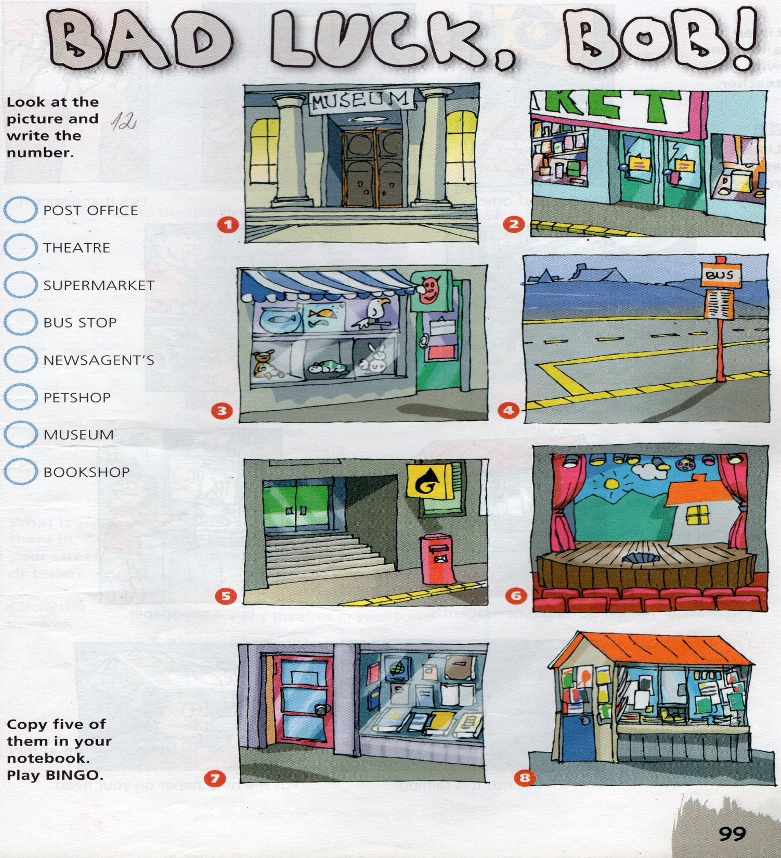
EXAMPLE: (PRIMJER)
Picture 1 - Museum

BAD LUCK, BOB
II. Read the story and complete the sentences. Look at the example.
II. (Pročitaj priču i dopuni rečenice. Vidi urađeni primjer.)
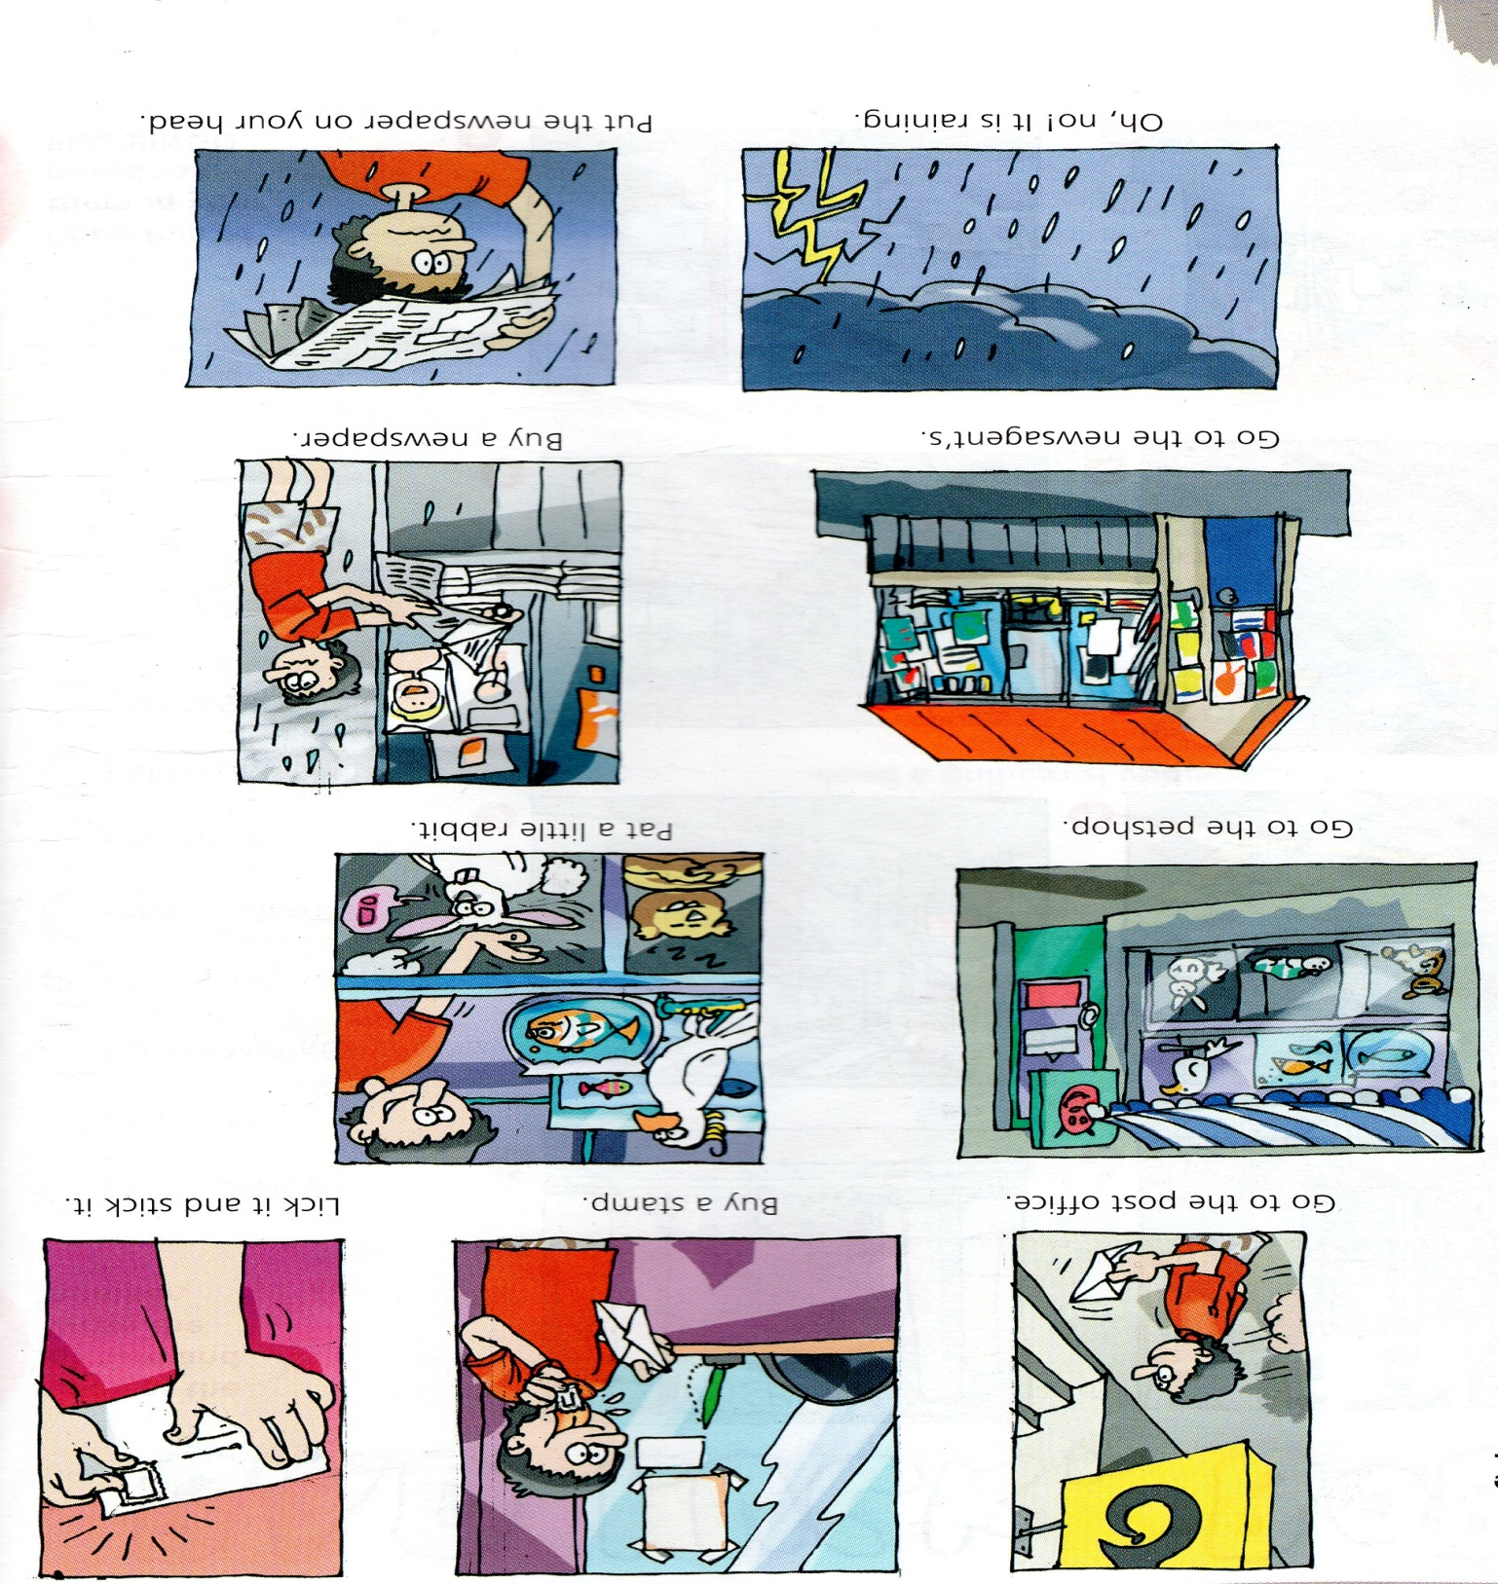

EXAMPLE: ( PRIMJER) Get on the ______ . Get on the bus.
1.Pat a _________ rabbit.
2.______ a stamp.
3.Lick it and ________ it .
4.Smile ______ .
5.My ________ is all black.
6.Go to the ________ stop.
7.Put the _____________ on your head.
8.Everybody is ____________ at you and ____________ .
9.Oh, no! It is ______________ .
10.________ for a bus .

III. Read the questions and underline the correct answer. Look at the example.
III. (Pročitaj pitanja i podvuci tačan odgovor. Vidi urađeni primjer.)

EXAMPLE: (PRIMJER)
1.Is there a post office in your street? Yes, there is. No, there isn't.

